# C++ Pointers

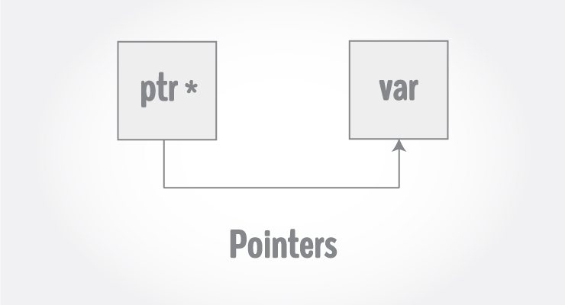

Pointers are powerful features of C++ that differentiates it from other programming languages like Java and Python.

Pointers are used in C++ program to access the memory and manipulate the address.

## Address in C++

To understand pointers, you should first know how data is stored on the computer.

Each variable you create in your program is assigned a location in the computer's memory. The value the variable stores is actually stored in the location assigned.

To know where the data is stored, C++ has an & operator. The **&** (reference) operator gives you the address occupied by a variable.

If var is a variable then, &var gives the address of that variable.

## Example 1: Address in C++

#include <iostream>

using namespace std;

int main()

{

int var1 = 3;

int var2 = 24;

int var3 = 17;

cout << &var1 << endl;

cout << &var2 << endl;

cout << &var3 << endl;

}

**Output**

0x7fff5fbff8ac

0x7fff5fbff8a8

0x7fff5fbff8a4

**Note:**You may not get the same result on your system.

The **0x** in the beginning represents the address is in hexadecimal form.

Notice that first address differs from second by 4-bytes and second address differs from third by 4-bytes.

This is because the size of integer (variable of type int) is 4 bytes in 64-bit system.

## Pointers Variables

C++ gives you the power to manipulate the data in the computer's memory directly. You can assign and de-assign any space in the memory as you wish. This is done using Pointer variables.

Pointers variables are variables that points to a specific address in the memory pointed by another variable.

### How to declare a pointer?

int *p;

OR,

int* p;

The statement above defines a pointer variable p. It holds the memory address

The asterisk is a dereference operator which means **pointer to.**

Here, pointer p is a **pointer to** int, i.e., it is pointing to an integer value in the memory address.

### Reference operator (&) and Deference operator (*)

Reference operator (&) as discussed above gives the address of a variable.

To get the value stored in the memory address, we use the dereference operator (*).

**For example**: If a number variable is stored in the memory address **0x123**, and it contains a value **5**.

The **reference (&)**operator gives the value **0x123**, while the **dereference (*)**operator gives the value **5**.

**Note:** The (*) sign used in the declaration of C++ pointer is not the dereference pointer. It is just a similar notation that creates a pointer.

## Example 2: C++ Pointers

**C++ Program to demonstrate the working of pointer.**

#include <iostream>

using namespace std;

int main() {

int *pc, c;

c = 5;

cout << "Address of c (&c): " << &c << endl;

cout << "Value of c (c): " << c << endl << endl;

pc = &c; // Pointer pc holds the memory address of variable c

cout << "Address that pointer pc holds (pc): "<< pc << endl;

cout << "Content of the address pointer pc holds (*pc): " << *pc << endl << endl;

c = 11; // The content inside memory address &c is changed from 5 to 11.

cout << "Address pointer pc holds (pc): " << pc << endl;

cout << "Content of the address pointer pc holds (*pc): " << *pc << endl << endl;

*pc = 2;

cout << "Address of c (&c): " << &c << endl;

cout << "Value of c (c): " << c << endl << endl;

return 0;

}

**Output**

Address of c (&c): 0x7fff5fbff80c

Value of c (c): 5

Address that pointer pc holds (pc): 0x7fff5fbff80c

Content of the address pointer pc holds (*pc): 5

Address pointer pc holds (pc): 0x7fff5fbff80c

Content of the address pointer pc holds (*pc): 11

Address of c (&c): 0x7fff5fbff80c

Value of c (c): 2

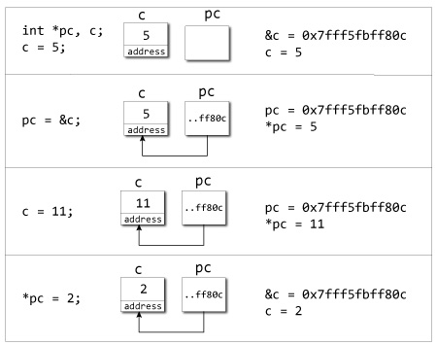

**Explanation of program**

* When c = 5; the value 5 is stored in the address of variable c - 0x7fff5fbff8c.
* When pc = &c; the pointer pc holds the address of c - 0x7fff5fbff8c, and the expression (dereference operator) *pc outputs the value stored in that address, 5.
* When c = 11; since the address pointer pc holds is the same as c - 0x7fff5fbff8c, change in the value of c is also reflected when the expression *pc is executed, which now outputs 11.
* When *pc = 2; it changes the content of the address stored by pc - 0x7fff5fbff8c. This is changed from 11 to 2. So, when we print the value of c, the value is 2 as well.

## Common mistakes when working with pointers

Suppose, you want pointer pc to point to the address of c. Then,

int c, *pc;

pc=c; /* Wrong! pc is address whereas, c is not an address. */

*pc=&c; /* Wrong! *pc is the value pointed by address whereas, %amp;c is an address. */

pc=&c; /* Correct! pc is an address and, %amp;pc is also an address. */

*pc=c; /* Correct! *pc is the value pointed by address and, c is also a value. */

In both cases, pointer pc is not pointing to the address of c.